**US Wildfire Prediction**

**Using Tableau.**

**EXECUTIVE SUMMARY:**

The document covers the entire mission of our wildfire prediction. Wildfires create a myriad of environmental, social, and monetary influences. Knowledge of each quick and long-time period influence of wildfire is crucial for powerful chance evaluation, coverage formulation, and wildfire control. The purpose of this document is to evaluate the provision of records on more than a few wildfire influences from federal, country, and neighborhood reasserts and to symbolize the character of those influences once they occur. We have located that records are summarized on the countrywide and country tiers for only some categories (wide variety of fires, acres burned, systems burned, and suppression cost), imparting coverage makers with an incomplete photograph of the overall influences from wildfires. For man or woman massive wildfires, our studies have proven that records are to be had for an extensive variety of environmental, social, and monetary influences, nicely past what's summarized on the countrywide or country tiers.

These indirect and enduring effects of wildfires may be significant, particularly for large flames in the wild land/city boundary. Wildfires are a common occurrence around the world, many of which can be quite devastating. The fires are consuming more territory, and due to human activity and environmental factors, there may be an ongoing boom of megafires. Several fires have also been predicted for the Amazon in 2019 in addition to Australia. The forests' capacity to support commercial, recreational, and subsistence activities is steadily declining because of the increasing wildfires. There has never been a more pressing need to preserve and restore forests. By forecasting future fires and focusing on preventive measures, proactive forest management can help reduce the number of wildfires.

However, most of the current wildfire prediction solutions do not remember the complete records that capture all of the significant components and additives that influence wildfire ignition. The results of previous studies on wildfire forecasting have been significantly less studied. Human factors are however taken into consideration more so that topographical and weather-related factors are predicting the likelihood of wildfires. Unbiased data can lead to inaccurate wildfire occurrence predictions, which can lead to poor management decisions for woodland resources. As a result, we suggest that more detailed records series at the wide range of wildfire effects, summarized at the national and global levels, could provide coverage makers with a more comprehensive understanding of wildfire affects and, in the end, serve to embellish modern society.

**Dataset Source:** <https://www.kaggle.com/datasets/4735dcf84228370db9a551c153b520cc6d9166aaeadffaf6205745c31c3585ae>

**DATASET DESCRIPTION AND RELATED WORK:**

The dataset presented here contains a spatial database of wildfires that occurred in the United States from 1992 to 2015. It is the third update of a publication originally generated to support the national Fire Program Analysis (FPA) system. The wildfire records were acquired from the reporting systems of federal, state, and local fire organizations. The following core data elements were required for records to be included in this data publication: discovery date, final fire size, and a point location at least as precise as Public Land Survey System (PLSS) section (1-square mile grid). The data were transformed to conform, when possible, to the data standards of the National Wildfire Coordinating Group (NWCG). Basic error-checking was performed, and redundant records were identified and removed, to the degree possible. The resulting product, referred to as the Fire Program Analysis fire-occurrence database (FPA FOD), includes 1.88 million geo-referenced wildfire records, representing a total of 140 million acres burned during the 24-year period.

Fig: Wildfire Dataset

**RESEARCH PROBLEM/ISSUES:**

To construct a relationship, we first want to analyze and display the dataset to identify any potential trends. Using Tableau sheets, dashboards, and stories, we are attempting to represent a few research topics and challenges that we discovered in the data. Some questions we would like to ask ourselves while analyzing and visualizing are:

1. What are the most Effected states in United States by Wildfire?
2. What was the Highest temperature recorded in Which state?
3. In Which month Most wildfire was recorded?
4. In which Year and state most vegetation was affected?
5. What are the measures taken to reduce the wildfire?

**EXPLORATORY DATA ANALYSIS ON THE DATA USING TABLEAU:**

1. What is the main cause for Wildfire in the United States?

The main reason for causing wildfire is because of the Lightening. The average fire size is 34,384.

Below image shows the Analysis of wild fire by using the Average Fire size and Putout time of this wildfire.

2. What are the most Effected states in United States by Wildfire?

Nevada is the most affected state with wildfire with average fire magnitude of 52.80.

The following image shows the state wise analysis of wildfire.

3.What was the Highest temperature recorded in Which state?

The State which is highly effected by wildfire is California. On an average 15.73% of remoteness is found in California. An interesting fact is that even though California is a coastal region but still has highest effect of wildfire.

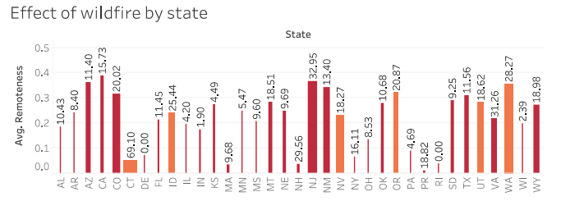

4. In Which month Most wildfire was recorded?

The highest temperature was recorded in the month of August. On an average it was 12.78%.

Least was recorded in the month of December with 0.43%.

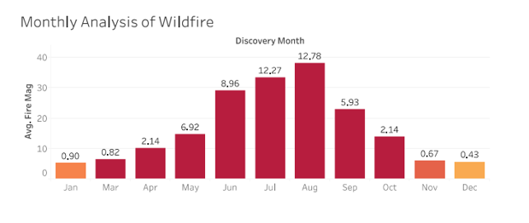

5. In Which Year and State most vegetation was affected?

1990 was the year in which the most vegetation was affected.

Central regions of US are highly effected.

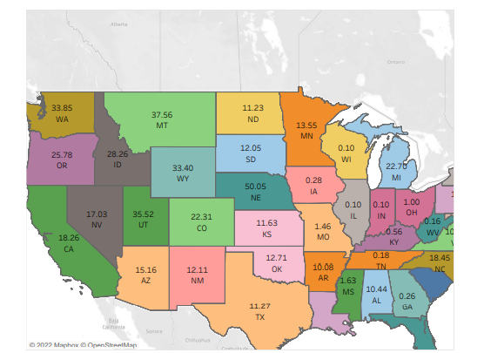

**DASHBOARDS:**

We have created 3 different dashboards using the sheets.

**Dashboard 1**: In the first dashboard we have compared the state wide wildfire with its effects in that respective state. Wildfire is analysed in each state depending on the fire magnitude whereas its effects are analysed by the remoteness created in each state.

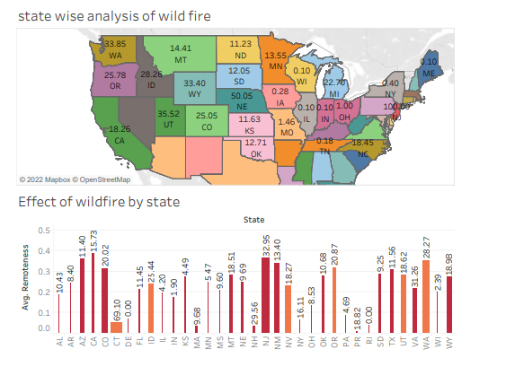

**DASHBOARD 2:**

In this we are trying to show the monthly effects of wildfire and the how they are affecting annually.

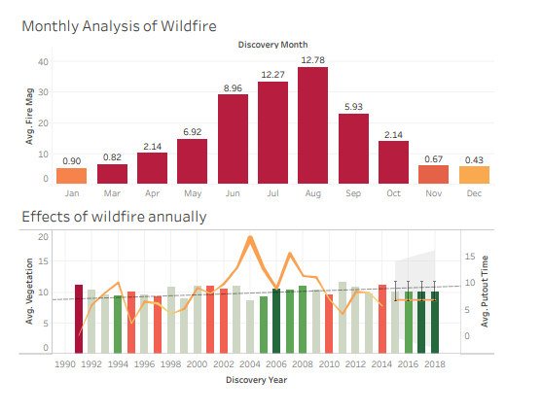

**DASHBOARD 3:**

In the third dashboard we are representing the different causes of wildfire and what is causing wildfire in each state.

**STORY:**

Showing the comparison between causes of wildfire and what is the cause for it in each state we have created a story. We can see that Arson is the main cause for the wildfire.

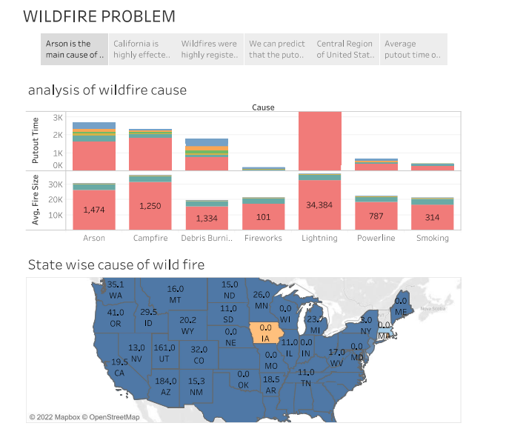

In step 2, we have analyzed the state wise effect of wildfire. California is the highly effected state due to the wildfire.

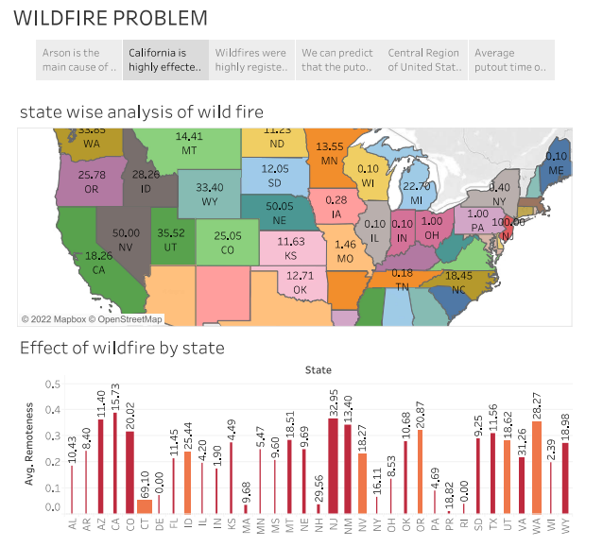

In step 3, we have compared the behavior of wildfire during different months of the year and different years.

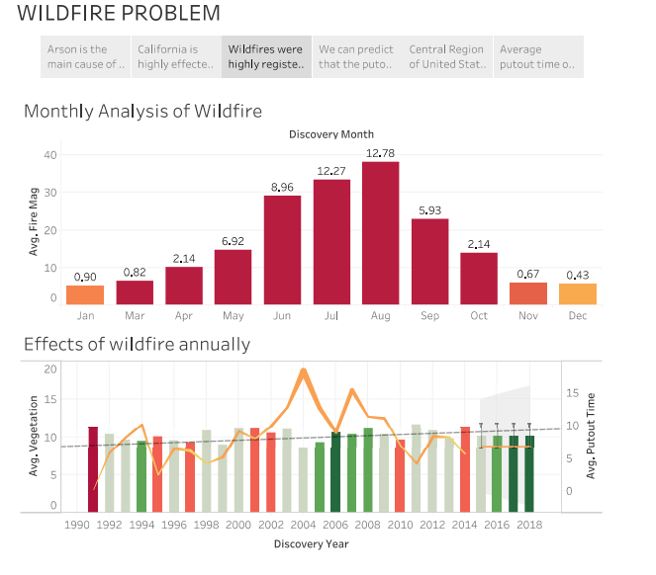

In step 4, Using the put of time and fire magnitude for the years between 1990 and 2014 we have predicted the putout time for the next four years from 2014 to 2018.

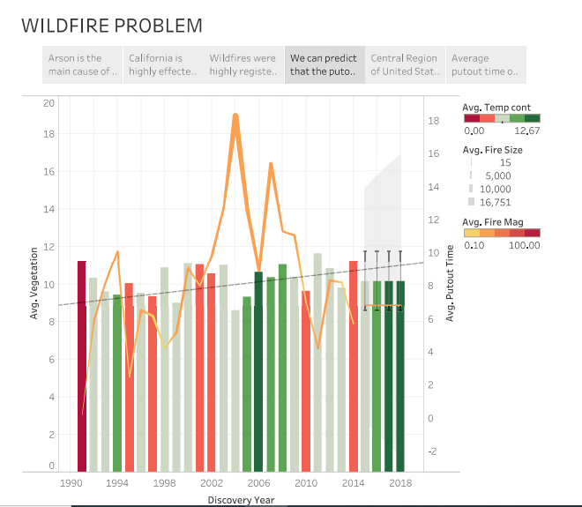

The step 5 is for representing the central region of the US and their avg fire magnitude, avg vegetation and the discovery month.

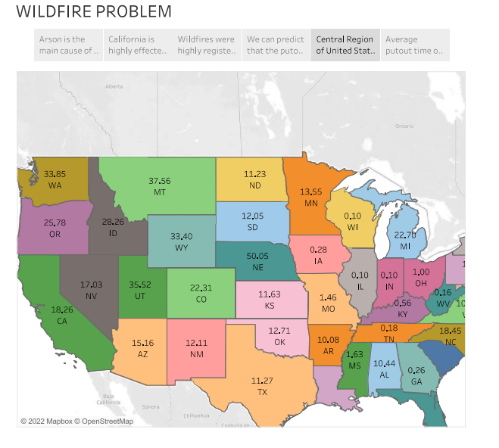

In step 6 of the story we represent the average putout time of the wildfire.

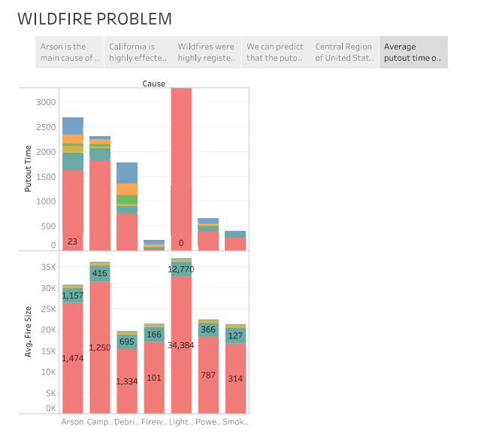

**REFERENCES:**

<https://www.kaggle.com/datasets/4735dcf84228370db9a551c153b520cc6d9166aaeadffaf6205745c31c3585ae>